Before

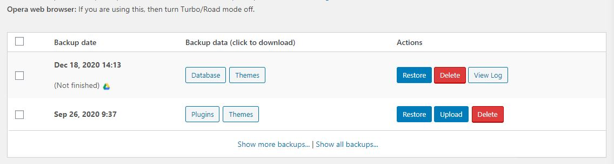

After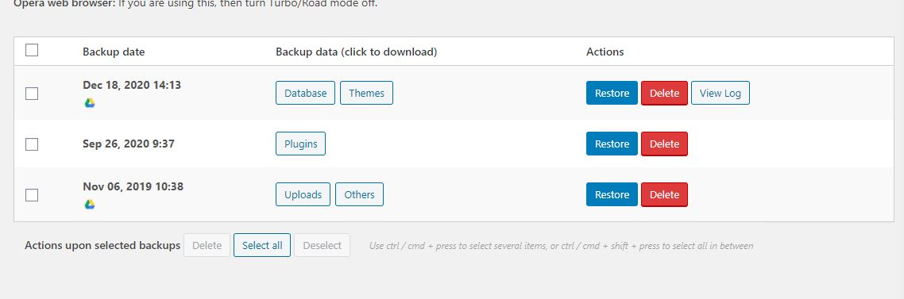

In after screenshot you can see I’ve took the successful back of the themes. You can also check that in the updraft section the WordPress dashboard

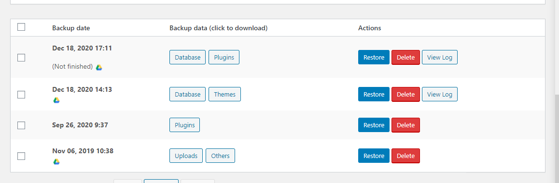

In this you can see that, I’ve also took the backup of plugins. It is uploading to google drive.

## What was the issue?

The issue may be caused by infected plugin. Or by the hosting. You need to contact to you hosting to check if there is any php error. It is important. If there is any error. Consider they have fixed that issue. It is cause by some infected plugin or website storage error.

Thing you must do is to update all the plugins. And also clean up you web storage.